|  |  |  |
| --- | --- | --- |
| **VEONEER STANDARD**  **Packaging Standard**  **VS246** | | |
|  | | |
| Author: Laura Miller | Approved by: Brian Toyonaga | |
| Version: 2.0 | Release date: 8/23/2023 | Pages: 12 |
|  | | |

**Table of Contents**

**VS246**

Introduction 4

1 Purpose 4

2 Scope 4

3 Responsibility 4

4 Packaging Requirements and Labelling 5

4.1 Veoneer material handling 5

4.2 Veoneer’s packaging environmental commitment 5

4.3 Weight limits 5

4.4 Stack ability 5

4.5 Standard dimensions 6

4.6 Cardboard boxes 7

4.7 Lids and pallet strapping 8

4.8 Returnable Packaging 8

4.9 Dangerous goods transports 9

4.10 Labelling conforming to VS244 9

4.11 Label placement 9

4.12 Non-Conforming packaging and labelling 10

4.13 Service Part packaging 10

4.14 Special requirements by different Veoneer Divisions 10

5 Packaging Approval Process (from RFQ to SOP) 10

5.1 Request for Quotation Process 10

5.2 Packaging test 10

5.3 Final Packaging Proposal (After Business Award) 11

5.4 Packaging Process Approval 11

6 Appendices 12

6.1 VS246 Appendix A – Packaging Proposal Sheet 12

7 References 12

8 Modification Index 12

# Introduction

VS246 defines the Veoneer standard for Supplier packaging and the Supplier packaging approval process.

# Purpose

To standardize and simplify the packaging solution to ensure optimal logistics costs without altering the integrity nor the quality of the component.

# Scope

This standard is valid for all production components shipped to Veoneer plants from both Internal and External suppliers.

All shipments to Veoneer plants shall follow the requirements defined in VS246.

The requirements outlined in this standard do not relieve the Supplier of their responsibility of providing Veoneer plants with quality parts.

Additional divisional or product line packaging requirements are posted on the Veoneer Partner Portal, APP.

# Responsibility

**Purchasing Management** is responsible to ensure that this standard is applied consistently.

**Logistics Management** is responsible to ensure that this standard is applied consistently.

**SQ Management** is responsible to ensure that this standard is applied consistently.

# Packaging Requirements and Labelling

## Veoneer material handling

Veoneer material handling process requires that all packaging entering Veoneer plants are safe to handle for plant operators.

## Veoneer’s packaging environmental commitment

Veoneer is committed to protect the environment in every phase of the supply chain. Therefore, packaging must be designed and used with respect to the following objectives:

* Maximize the number of parts per box (Optimize box utilization)
* Stackable pallets (Optimize logistics mode utilization)
* Minimum usage of bubble foil or material wrapping
* Recycle to manage waste (cardboard boxes, bubble foil, and wrapping)
* Returnable package is foldable, stackable, or can be “nested” in order to reduce transport space requirements.

## Weight limits

* Maximum weight limit per box is 12 Kg. / 26.5 lbs
* Maximum weight limit per pallet is 500 Kg.
* Any exceptions to these weight limits must be agreed upon between Veoneer plant Logistics Manager and Supplier.

## Stack ability

All incoming packaging shall be designed and constructed to enable one (1) pallet to be “stacked” on top of another pallet with the same weight.



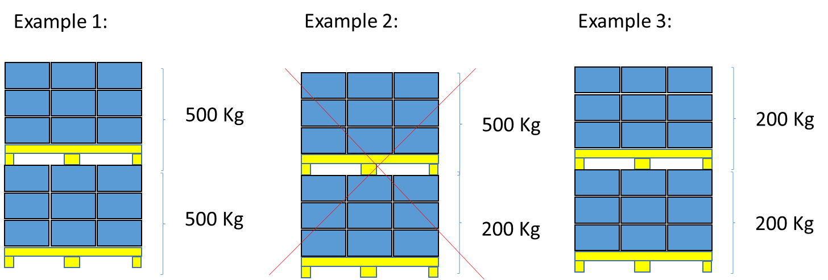

* To ensure a proper stack ability,
  + The top layer surface of the pallets shall be flat. No single nor loose cardboard is allowed.
  + Pallet packaging design shall allow as a minimum a stack ability factor of 2 (one pallet on top of another pallet with the same weight).

If quality issues arise after SOP, Veoneer might agree to non-stackable pallets. If so, Supplier is responsible to label the pallet with a “non-stackable” label.

## Standard dimensions

Standard packaging dimensions are required by Suppliers unless approved by individual plant Packaging Engineer.

|  |  |  |  |  |  |
| --- | --- | --- | --- | --- | --- |
| Supplier | Pallet size (L x W in mm) | Pallet overall height max in mm | Max full pallet weight in kg | Box size (L x W in mm) | Max full box weight in kg |
| Overseas | 1170 x 770 | 1000 | 500 | 585 x 385 | 12 |
| 385 x 292 |
| 292 x 192 |
| Local | 1200 x 800 | 600 x 400 |
| 400 x 300 |
| 300 x 200 |

Remark: Dimensions are shown based on outside dimensions.

* Supplier shall use the packaging and pallet type required by Veoneer plants
* When multiple Veoneer plants are using the same part, Local and International packaging may differ in packaging type and dimensions.
* For intercontinental transports, pallets and collars shall comply with IPPC (ISPM 15) International Standard for Wood Packaging.
* Forklift guide pockets shall accommodate forks in the specific region.
* Any exception design supporting container or truck utilization shall be reviewed and approved by Veoneer plant logistics.
* When necessary, Veoneer logistics can decide different packaging for different delivery point.

## Cardboard boxes

Veoneer Standard Cardboard Boxes as defined in 4.5, are intended to be used as cost efficient stackable one way packaging with a preferred “shoe box design”.



“Shoe box design”

Nevertheless, other types of cardboards might be used - if approved –

In that option, they must fulfill the below minimum mandatory expectations :

* No kind of cutter shall be used to open (for obvious health and safety reason and to avoid to damage parts-in)
* Should be easily stored open on the shelves along the assembly lines (no embarrassing flaps moving along)
* Shall protect the integrity of the goods and the cleanliness till the assembly line shelves.

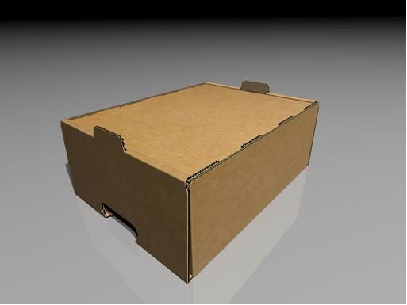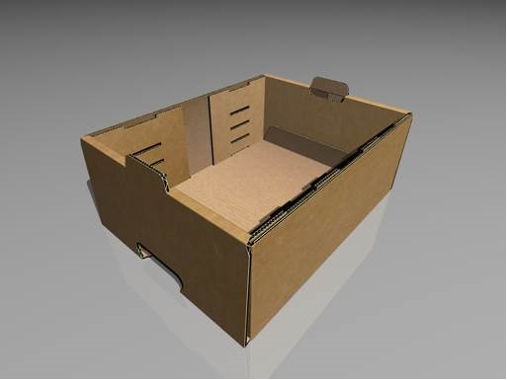

“Other option example”



“Example NOK”

The standard for strength may be different depending on mode of transportation such as truck, rail, ocean, or air. Boxes may be re-used and shipped to an additional destination. Standard cardboard boxes are encouraged to be used by the Supplier for flows to both Veoneer and other companies.

Returnable packaging shall be used instead of cardboard packaging in cases where suppliers are within distance and logistics costs supports returnable packaging rather than cardboard packaging.

## Lids and pallet strapping

To keep boxes and pallets together, a strap pallet sized lid should be placed on the top of the boxes.

Pallet banding with straps made of plastic might be required dependent on the mode of transportation or the distance of travel. The amount of banding depends on the weight and the mode of transportation.

Stretch film is not required but might be requested by specific Veoneer plants.

**Metallic or steel straps shall never be used**.

## Returnable Packaging

When a returnable packaging is approved, the supplier must submit an alternative expendable packaging proposal to be used in the case of returnable container shortages. Alternative packaging must be similar in size to returnable packaging and contain the same quantity of parts.

The Supplier must ensure the daily management of returnable containers for inventory control.

The Supplier is responsible of cleaning of returnable containers and racks, including removal of all AIAG labels and other labels.

The Supplier is responsible to keep containers and racks clean, before filling containers with productive parts.

Veoneer and Supplier shall perform a returnable packaging stock count at least (1) once per year or whenever requested by Veoneer.

Supplier is required to check monthly inbound and outbound receipts for returnable packaging and reconcile with Veoneer plant specific (owner of returnable containers).

Supplier must notify Veoneer about any shortages of empty returnable at least 3 days before shipping the parts using the alternative packaging with approval.

Cost for alternative packaging must be agreed at the same time as standard packaging approval.

## Dangerous goods transports

If the Suppliers products and shipments includes transportation of dangerous goods, it is the Suppliers responsibility to follow the international rules and regulations depending on the shipment type. These are ADR, RID, ADNR, IATA, DGR and IMO, CFR 49.

Internal Veoneer Suppliers shall follow VS245 (Veoneer Standard Transport of Dangerous goods).

## Labelling conforming to VS244

As defined in VS244, Box labels are required on individual boxes to ensure traceability in our production processes according to VS004.

Country of origin may be required on each box depending on ship-to country.

Pallet labels are required to ensure all logistics partners know where to transfer or ship the material. Also, pallet labels are required in the receiving, warehousing, and material handling processes in Veoneer plants.

## Label placement

Supplier are responsible to ensure that labeling complies with VS244.

All Suppliers can print correct labels, by using the application through the Veoneer Partner Portal unless EDI connection already set up to VS242 and VS244.

Labels must be linked to Advance Shipping Notification (ASN) by Serial or Pack Number, according to VS242 and VS244

* Pallet and box labels should not be applied on the external stretch-wrapping foil due to the high risk of separating the labels from the box/container when the external foil is removed.
* Master Label (Pallet Label) shall be placed in the lower left corner of the pallet if no other instructions or label holders are available, on 2 adjacent sides. Box label should be placed on the short side of each box.
* Returnable boxes labels shall be placed in label holders only. Fully glued labels should only be used on hot stamped areas but NOT on returnable packaging.

When needed, Veoneer or its nominated freight company may ask for additional labeling to facilitate easier movement of goods between any two locations. Such requests will be discussed on a case by case basis.

In regards to Fiberboard boxes, box labels shall be fully glued to the cardboard box.

All information (barcodes and text) must remain visible. For label design and content, please see VS244.

All shipments have to be prepared with a copy of the shipping documents attached. These documents have to be placed in a plastic pocket on the short side of one of the pallets of the complete shipment. A copy of the delivery notice shall be provided to the driver.

## Non-Conforming packaging and labelling

Shipping goods in a non-standard packaging will result in formal NCM complaints to the Supplier that will demerit the Delivery Rating (VS051).

## Service Part packaging

No returnable packaging is allowed unless written approval by Veoneer.

The “Minimum Order Quantity” will be the quantity of one single spare part packaging defined by the agreed upon packaging proposal sheet.

Even before end of production (EOP), Veoneer is allowed to Order in Service Part packaging to serve dedicated Service Part Organization and plants. Veoneer will specify the Packaging unit (*see above: Minimum Order Quantity*) and the Handling unit in the Separate Packaging proposal sheet / Service Parts.

If there is no separate Packaging proposal sheet / Service Parts specified by Veoneer before EOP, the Supplier must contact the responsible planner at Veoneer three months before end of production and complete a Request Packaging proposal sheet / Service Parts.

## Special requirements by different Veoneer Divisions

Special requirements for Veoneer Europe, Veoneer China, Veoneer North America, Veoneer South America, Veoneer India, Veoneer Korea, or Veoneer Japan are stored in the Veoneer Supplier Manual (VSM) in the “Local Documents”

# Packaging Approval Process (from RFQ to SOP)

## Request for Quotation Process

The supplier shall quote a packaging proposal as defined in this standard. This packaging proposal shall be provided in the Supplier Cost Breakdown (SCB) template. This template can be found in the Request for Quotation Process (RFQ) under Section 3 (“Packaging & Logistics”).

Also, the supplier shall submit a Team Feasibility Commitment template (TFC) together with the Supplier Cost Breakdown (SCB) template. In this TFC, the supplier shall validate that the quoted packaging proposal is complete, correct, and feasible according to VS246 standard.

## Packaging test

Upon request, Supplier shall prepare a packaging test report to ensure that correct packaging has been chosen for stack ability. The test report should be included in the APQP documentation and approval. The test must be validated and accepted by each receiving plant Logistics, Quality, and IE Departments of Veoneer. Test report should be sent to Veoneer for approval prior to serial deliveries.

## Final Packaging Proposal (After Business Award)

If Supplier is awarded the business by Veoneer, the Supplier is required to submit a final and detailed Packaging Proposal Sheet (PPS) to the RFQ owner. This submission of the PPS should take place right after the award is communicated.

## Packaging Process Approval

Veoneer Packaging proposals shall be approved through the signed PPS template and always before Toll Gate 2 “Production Definition Approval”.

The Packing approval is the responsibility of the Plant Logistics representative and the Plant Supplier Quality representatives. Each part number must have an approval from these representatives.

In cases where the Supplier will be shipping to multiple Veoneer plant destinations, the approval is required from each Veoneer plant.

Packaging is considered to be approved only after receiving the “Packaging Proposal Sheet” signed by Plant Logistics representatives (who should ensure that Plant Supplier Quality representatives approved as well)

The final approval of packaging shall be ready, at the latest, at Toll Gate 3 “Product on Market approval” and must be closed by Toll Gate 4 (Reference VS403)

Veoneer shall evaluate packaging, performance based on the transport, unloading, storage, stacking in the warehouse, and internal handling to production line. If the packaging proposal is rejected – a new proposal must be submitted to Plant Logistics representative for approval and returned to supplier.

All changes from “quoted packaging” to the final approval, shall be validated by Veoneer.

# Appendices

## VS246 Appendix A – Packaging Proposal Sheet

Exception China LIS “Logistics Information System”; contact China Logistics Packaging Analyst by plant to access databVSe.

Exception Markham suppliers – Use the Markham ONLY packaging spec.

All other Veoneer facilities suppliers must use the “Veoneer Packaging Sheet” blank.

# References

VSM Veoneer Supplier Manual www.Veoneer.biz

VPP Veoneer Partner Portal www.Veoneer.biz

PPS Packaging Proposal Sheet www.Veoneer.biz

VS004 Veoneer Standard Traceability

VS051 Veoneer Standard Supplier Rating

VS057 Veoneer Standard Sourcing Process

VS244 Veoneer Standard Package & Transport Label

VS245 Veoneer Standard Transport of Dangerous goods

VS242-1 Veoneer Standard EDI Messages – 1 DDELFOR

VS242-2 Veoneer Standard EDI Messages – 2 DESADV

VS242-3 Veoneer Standard EDI Messages – 3 DELJIT

VS242-4 Veoneer Standard EDI Messages – 3 INVOIC

# Modification Index

|  |  |  |  |
| --- | --- | --- | --- |
| **Version #** | **Date / Author** | **Modification** | **Purpose** |
| 1.0 | 01-Apr-2018/ J. Thomson | First version |  |
| 2.0 | 17-Aug-2023 | Added Markham only packaging sheet to Appendix A with explanation. |  |