|  |  |  |
| --- | --- | --- |
| **Veoneer Excellence System Standard**  **VES Assessment**  **VESS 001** | | |
| Distribution to: VES Managers, Plant Managers & VES Committee members | | |
| Author: Markus Billock | Approved by: Thomas Moberg | |
| Version: 4.0 | Release date: 25 March 2020 | Pages: 10 |
|  | | |

**Table of Contents**

Introduction 3

1 Purpose 3

2 Scope 3

3 Responsibility 3

3.1 Site Manager 3

3.2 VES Manager 3

4 Procedure 3

4.1 Assessment Participants 3

4.2 Frequency 3

4.3 Basic sections of the VES assessment (Appendix A – VES Assessment): 3

4.3.1 Instructions & Definitions 4

4.3.2 Visuals and Analysis 5

4.3.3 VES Elements 7

4.4 VES Guideline 8

4.5 Actions and main take a ways 8

4.6 Calibration Process 8

4.7 Calibration agenda and pre-work 9

4.8 Gold and Platinum Ceremony 9

4.9 Summary 9

5 References 9

6 Appendices 9

6.1 Appendix A – VES Assessment 9

6.2 Appendix B – Assessment Guideline 9

6.3 Appendix C – VES Assessment Training Module 9

6.4 Appendix D – Calibration Agenda and Pre-Work 9

7 Modification Index 10

Introduction

# Purpose

To provide a clear vision of what is required to achieve operational excellence.

To define the gap between where we are today and the benchmark level for each VES-element, and actions required to close the gap.

# Scope

This assessment should be used for production plants including the support functions related to the plant organization (e.g. plant quality but not country IT).

# Responsibility

## Site Manager

It is the responsibility of the Site Manager to ensure the proper resources are assigned to complete the VES Assessment. Additionally, the Site Manager is responsible to ensure actions are documented and proper follow up is applied to move the site forward.

## VES Manager

It is the responsibility of the site VES manager to plan and execute the VES Assessment at the right frequency and to include the right participants.

# Procedure

## Assessment Participants

Include all levels & Functions (Cross Functional)

* Site Manager
* Manager / supervisor
* VES
* Line leader / operator
* Functional Support areas

## Frequency

Self-Assessment to be conducted one time each quarter (minimum). Calibrated assessment (see 4.6) to be conducted every other year. In addition, any site achieving gold or platinum levels must call for a calibration to validate the results.

## Basic sections of the VES assessment (Appendix A – VES Assessment):

* Instructions & Definitions
* Visuals & Analysis
* VES elements & Calculations

### Instructions & Definitions

Detailed instructions help the user to understand how to get the most out of the VES Assessment.



Definitions are provided for key sections and words used during the assessment.



### Visuals and Analysis

The Assessment Dashboard is a visual display of the assessment results. The dashboard is divided into 3 basic sections as follows:

1. VES House – The level of achievement for each element is represented by colors.



1. Strengths and Opportunities Pareto – All elements are shown in order from strongest to the biggest opportunity. The Pareto is linked to the QOS Tab.

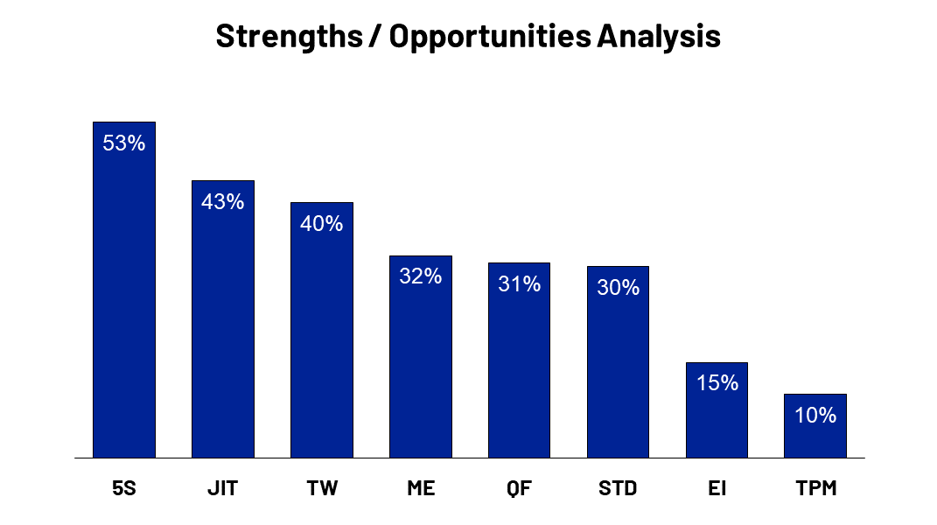

1. Overall Rating – The result of all scoring is indicated by a percentage and level (Basic, Bronze, Silver, Gold or Platinum)

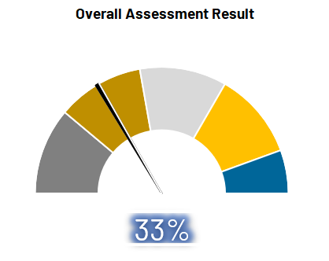

Note: The VES Assessment Dashboard must be displayed in at least one location in the site.

The Assessment Analysis Tab – Graphs are provided to help the user see where strengths and opportunities exist for Leadership, Workplace and each element of the VES Assessment.

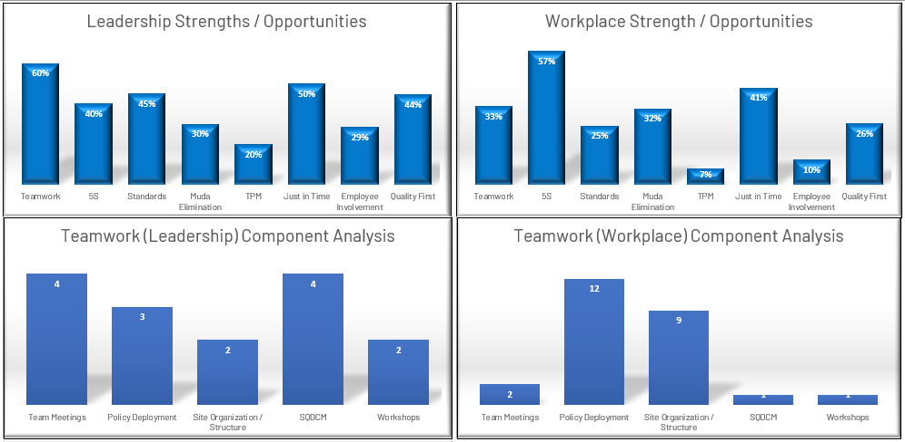

The QOS Tabs are based on VS061 and provides historical data of the progress in assessment result. The QOS chart is created manually.



### VES Elements

There are 8 elements in the VES House. All 8 elements must be evaluated during the VES Assessment for a complete analysis of VES Maturity.

1. Each element starts with a mission statement. This should be reviewed by the team prior to evaluating each section. Within each element there are components for specific VES Principles.
2. Each element contains 5 levels for Leadership and Workplace. Statements within each level help the user to determine where the site is performing. Leadership statements are focused on what types of behaviors we see from the site management team. Workplace statements are focused on what kind of verifiable evidence we should see at the Genba.
3. Each element also contains a “Width” score (1-3) in the far-right hand column. This is used to determine how wide spread a principle is within the site. In other words, it is a multiplier that adds to the score as full deployment is reached.



1. A calculation tab is provided to standardize the sample size and formulas for objective statements within each VES Element and component. Yellow boxes require data input and Green boxes are the output. This data should be prepared before the Assessment starts.



## VES Guideline

An assessment guideline is provided to help the user understand how to answer each component in each element. This is not mandatory but is available for users who may not otherwise feel comfortable selecting the right level to show the rank for a given component. (See Appendix B – Assessment guideline)

## Actions and main take a ways

All actions that come as a result of the VES Assessment need to be linked to helping the site to achieve their main KPI’s. Additionally, the actions must be prioritized to align with the site Policy Deployment. Although a tab exists for the purpose of documenting the main take a-way from each element, the actions will be tracked in the sites normal actions plan (LOP).

## Calibration Process

At the frequency defined in section 4.2 a pair of VES Assessment calibrators will come to each site and lead the assessment. The calibrator along with the site leadership will participate in a discovery exercise to define the road map going forward. One of the key drivers behind the calibration is to give an objective view of the plants VES status.

The local cross-functional team for each Assessment Element should be invited to the calibration. If there is a risk of language barrier, make sure to have a translator present to include all participants in the discussions.

Calibrators should not belong to the assessed Plant’s organization.

The expected duration for a calibrated VES Assessment is 2-2,5 days.

## Calibration agenda and pre-work

A sample agenda is provided as a general outline of how an assessment calibration will be conducted including a list of preparations. (See Appendix D – Calibration agenda and pre-work)

## Gold and Platinum Ceremony

A site that has achieved gold or platinum levels must call for a calibration to validate the results. After validation the site should plan a celebration ceremony. EVP Operations should be invited together with other applicable Senior Management functions. The purposes with the event are to share success stories, acknowledge the achievements and celebration for the plant team together with Senior Management.

## Summary

1. VES does not hide problems
2. Use the assessment to drive improvement
3. Use the tools (dictionary, etc.) to aid in filling out the assessment
4. Use the strength of a cross functional team
5. Use the assessment to clarify what is the desired culture.

# References

VS061 - Presentation of Continual Improvement Processes

# Appendices

## Appendix A – VES Assessment

## Appendix B – Assessment Guideline

## Appendix C – VES Assessment Training Module

## Appendix D – Calibration Agenda and Pre-Work

# Modification Index

|  |  |  |  |
| --- | --- | --- | --- |
| **Version #** | **Date / Author** | **Modification** | **Purpose** |
| 1.0 | *2015/04/02 CH* | Initial release | Standardization |
| 1.1 | *2015/11/17 DJ* | Added Appendix C (Compliance Audit Checklist), Clarified cross functional team involvement (4.1) and expectations for display (4.3.2) | Provide a clearer expectation for what compliant means. |
| 2.0 | *23 Nov 2016 / RB* | Added section 4.3.3 for Zero Defect Pre-requisite dashboard. | Provide focus on key elements to achieve Zero Defects. |
| 2.1 | *07 Dec 2016 / DJ* | Modified wording in section 4.3.3 for definition of unacceptable quality performance | Better Clarity of expectation |
| 3.0 | *2 Jan 2018 / DJ* | Added statements for all elements and components. Removed evaluation of behaviors, metrics and results. Added Performance evaluation. Added Analytics tab. Added Calibration process. | Improve the usefulness of the Assessment. Calibrate the results and compare performance to VES Maturity. |
| 3.1 | *2 Apr 2018 / DJ* | Appendix A - Fixed grammar and or clarified several statements in the VES Assessment. Appendix B - Updated the Trend and Stability Analyzer to reflect 24 months instead of weekly data. Adjusted the visual management of the roof to be consistent with the pillars and foundation. | Clarify understand and improve the accuracy of the trend and stability analyzer. |
| 4.0 | *25 March 2020 / MB* | Conversion Autoliv to Veoneer. Removal of Performance section of the VES Assessment. | First launch as Veoneer document |